**Task 1 - Session charter**

**Charter** - Analyse the interface of the website <https://planetakino.ua/>

**Areas** - Main page

**Test Environment** - UAT

**Start** - 24.06.2022 10:00 am

**Tester** - Nataliia

**Duration** - 60 minutes

**Task Breakdown** - Fonts styles and sizes,

Buttons design,

Animations,

Images

**Testing Notes**

* Verify design and interface of the main page

**Data files** - screenshots

**Bugs** - Bugs found during testing. Each defect is described in bug report.

**Session Setup Time** - 20%

**Test Design and Execution** - 80%

**Task 2 - Tour Description**

**А) The Supermodel Tour -** This tour is not about function or substance; it’s about looks and first impressions. During the Supermodel tour, the focus is not on functionality or real interaction. It’s only on the interface.

I chose this tour because of my interest in testing website interfaces and finding UI bugs.

**B) Check-list**

**Fonts**

1. Verify font sizes on the main menu
2. Verify font types on the main menu
3. Verify that there are not more than 3 fonts on the page
4. Verify that there are not more than 3 font sizes on the page
5. Check elements aligments
6. Check margins between grid elements
7. Check the button’s size
8. Check the button’s color
9. Verify localisation
10. Verify default language
11. Verify social media buttons on the footer
12. Check that inactive buttons displayed in grey color
13. Check that the scroll button appears when it needs
14. Check the alignments of elements on different display layout
15. Check the alignments of elements on different devices
16. Verify that logo redirects to the main page
17. Check if each movie has its own poster
18. Main page should have a title
19. Check main page for broken images
20. Check main page for broken links

**Bug reports**

**ID** - 001

**Title:** Chat icon and scroll arrow are not aligned

**Environment:** iPhone XR, Samsung Galaxy S20 Ultra

**Severity:** Minor

**Priority:** Medium

**Steps to reproduce:**

* Go to <https://planetakino.ua/> (mobile device)
* Scroll down
* Pay attention on the chat icon and scroll arrow

**Actual result:** Chat icon and scroll arrow are not aligned

**Expected result:** Chat icon and scroll arrow are aligned with respect to each other

**Attachments:** 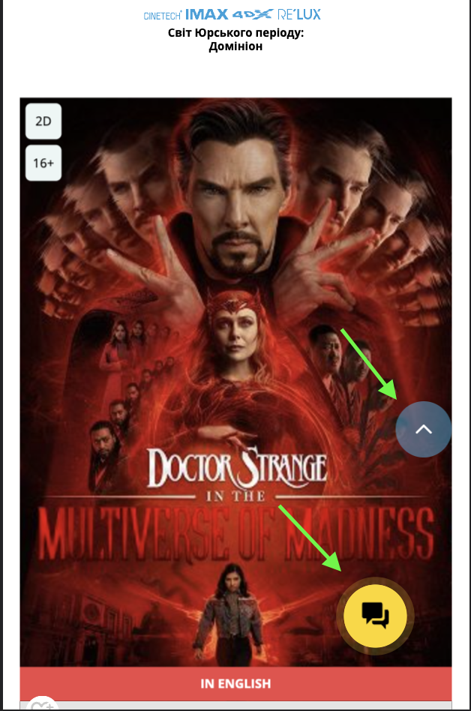

**ID:** 002

**Title:** The films’ posters in carousel is partly hidden under the main menu

**Environment:** MacBook Air, Google Chrome browser

**Severity:** Minor

**Priority:** High

**Steps to reproduce:**

* Go to <https://planetakino.ua/>
* Pay attention to films’ posters in posters carousel

**Actual result:** Posters in carousel are partly hidden under the main menu

**Expected result:** Posters have to be displayed in ful size

**Attachments:**

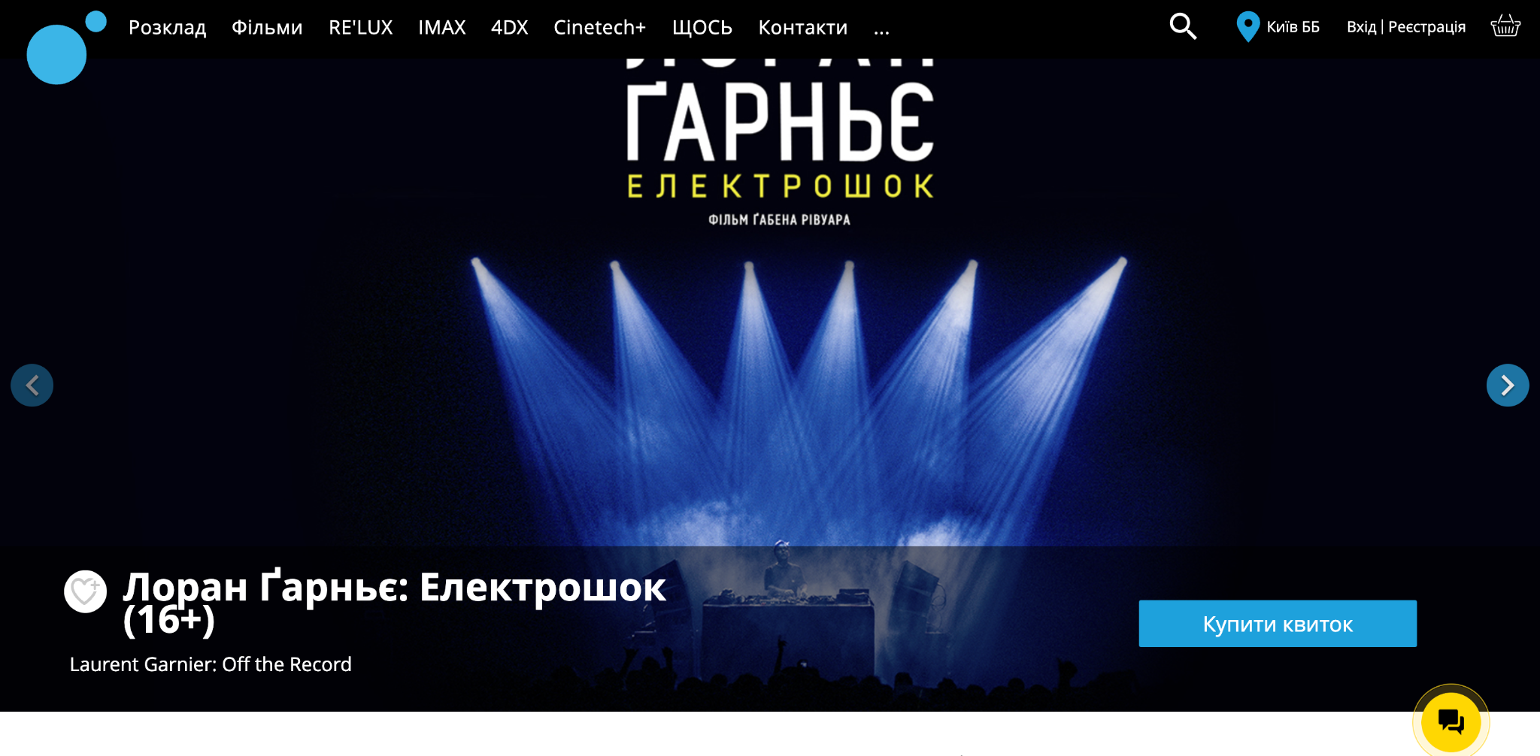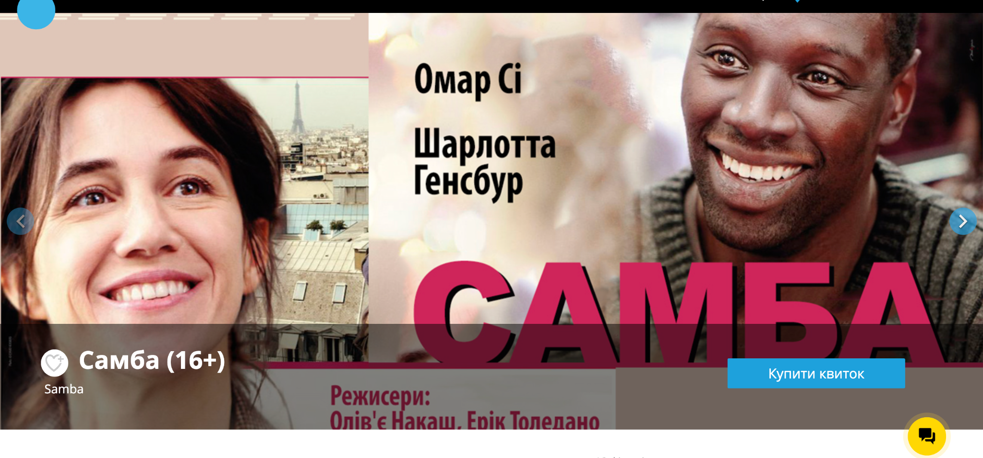

**ID:** 003

**Title:** Some of the film’s posters are not displayed because of broken image

**Environment:** MacBook Air, Google Chrome browser

**Severity:** Critical

**Priority:** High

**Steps to reproduce:**

* Go to <https://planetakino.ua/>
* Click on the search field button
* Enter “30” to the search field
* Pay attention to films posters

**Actual result:** Some films posters are not displayed because of broken images

**Expected result:** Films posters have to be displayed correct

**Attacments:**

